The circuit report

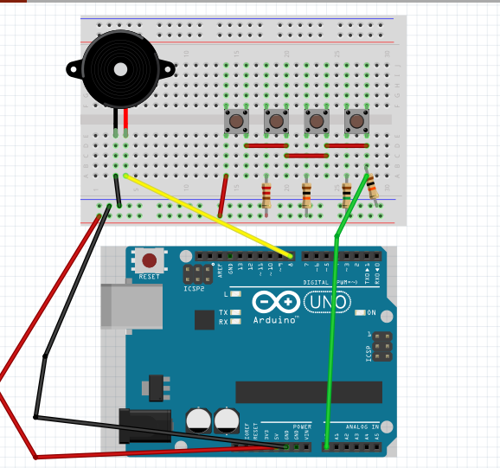

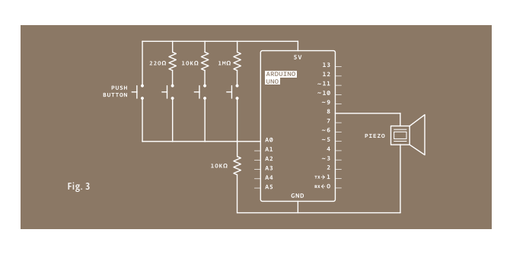



Set an integer array to store different HZ.



To get kyVal from A0 and print keyVal.

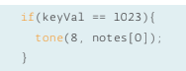

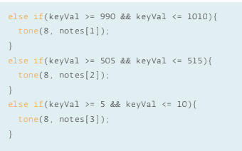

Through press switch to change keyVal, use if function to get different tone with different situation.